- Go to my.asu.edu and click profile.
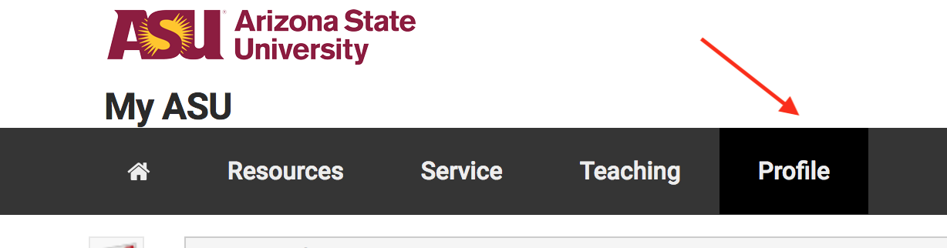

- Click on any of the links for Address under the Contact Details section
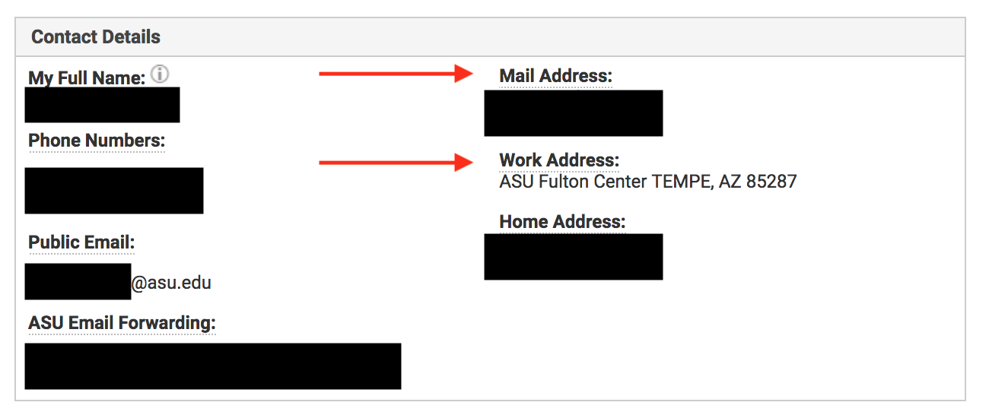

- If you already have a work address, click the pencil icon. If not, click Add a new address
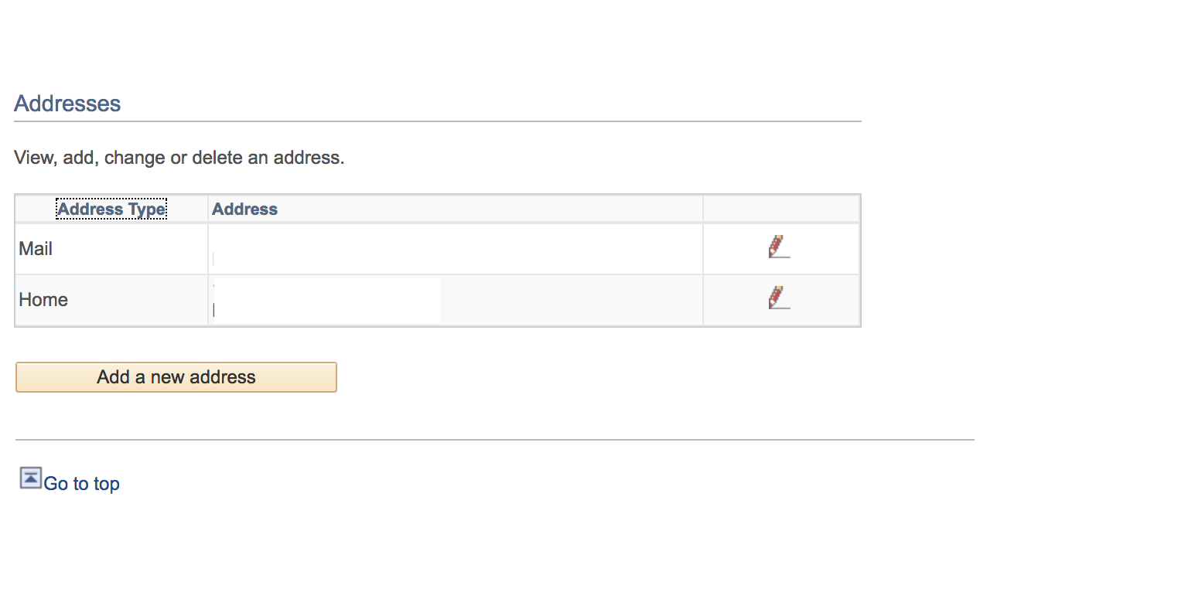
- Fill out the address field as noted below. Click Ok.
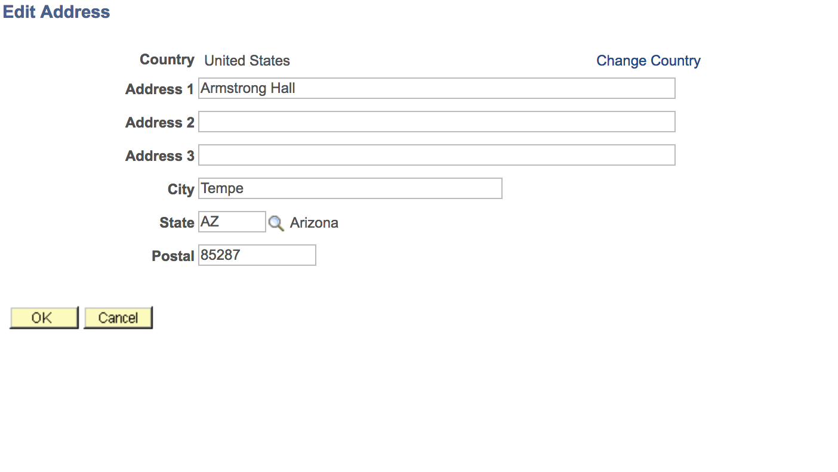
- On the next screen, select Campus Location.
Optional: Select a future date for the address to take effect.
Click Save.
