ASU Events how-to guide

- Sign in top right corner using ASURITE

- Below top featured events will be a link called My Events. Click that, then click “Add event”

- Fill out the form as follows:
- Event name: Title of the event
- Event Date and Time: Include day of event and starting and ending time. ***If your event has multiple days, please see the how-to on Repeat events at the end of this guide.
- Event Date/Time Description: Only fill this out if you have extra, detailed information to give about the time and day of your event.
- Body: Tell us what the event is about. Can add hyperlinks, extra photos, bolding, etc. Please use AP style.

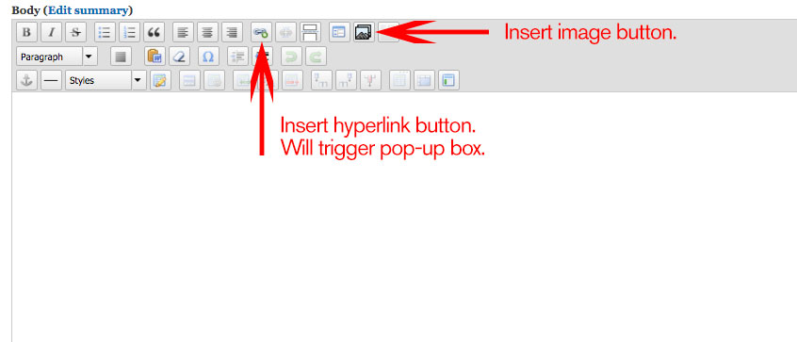

- Insert image (good size to aim for is at least 640 x 360 px.) Can browse to desktop or find image in library
- Price: Pick a price level, and enter any extra details in the price description
- Ticketing/RSVP: Optional area to insert a call to action, such as buy tickets, RSVP, access more info, etc. Type in what you want the button to say and then insert a URL
- Download file: Optional area for any downloadable content. Browse to file on desktop and then fill in what you want the Download button to say. (NOTE: Keep this button text and the RSVP button text short)
- Event contact: Optional public-facing contact information for the event
- Display Rules:
  - Display Tags: Ignore, for editors only
  - Mark the event for potential promotion on the events homepage. NOTE: only events with good art, and fairly broad topics will be selected
  - Do not list: Allows your event to be unsearchable on the events site – good for private events you want for your feed only
- Tagging:
  - Event Type: dropdown choice to indicate what type of event it is.
  - Event Topics: Type in based on pre-selected tags. (See separate tagging guides for help.)
  - Location: Type in general campus location (based on pre-created tags: see separate guide for help)
  - College Unit: Type in your name, and include The College of Liberal Arts and Sciences (separated by a comma).
  - Interests: Type in general interest. (Based on pre-created university-wide tags. See separate guide for help)
  - Herberger Feed: For use by Herberger units only.
  - Constituent type: Type in event audience (Based on pre-created university-wide tags. See separate guide for help)
NOTE: To choose more than one tag in all fields, use a comma and start typing in new tag.
- Event Location:
  - Event Location Title: Enter name of venue or building, including room number
  - Event Location Link: Used for off-campus events
    - Title: Address of location
    - URL: Link to Google map
  - Location Website: Optional field to include venue or location’s website
  - Select Campus Map (for ASU campus locations)
    - Choose appropriate campus
    - Height: leave as default
    - Display campus selection menu: leave as default
    - Location Selection Form
      - Choose Buildings, will trigger more categories below.
      - Pick from sub-category, if unsure, choosing more than on sub-category will give more options.
      - Check correct location
    - Description: Optional field for any additional location information, such as parking.

- Scroll to bottom and select Save as draft.

- This will take you to a page where you can preview your event. If you have more changes, click on new draft and save again. If you are ready for it to move on, there are two options:
- Save event as ready for review (can be found at dropdown on top of event page) — use this option only if you are sending it to an additional approver in your unit.
- For event approvers: Change dropdown to Ready to Publish. This will put it in the ASU Event editors’ queue.

- Congrats! You’re good to go. Please give your event at least 24 hours to be published, after it’s been send to Ready to Publish.

***Additional instructions for repeat events.

- Insert date information for first day of event only (not the range).
- Click on repeat
  - Choose from repeat information. Options include daily, weekly, monthly etc. Each option has additional clarifiers you can choose from.
  - You have the event stop repeating after a certain amount of occurrences or on a certain day.
  - If there are extra days or times that do not apply to the first day of the event, click on include dates.
    - Fill in the days of those events, and the specific time range below in Performance Times.
  - If there are days you need to exclude from the range, click on exclude dates and insert those specific days.
- You can give more details about the range of times in the Event date/time description below.

